Mad Monkey app download to signup page:
First page after downloading our app in phones for sign up:
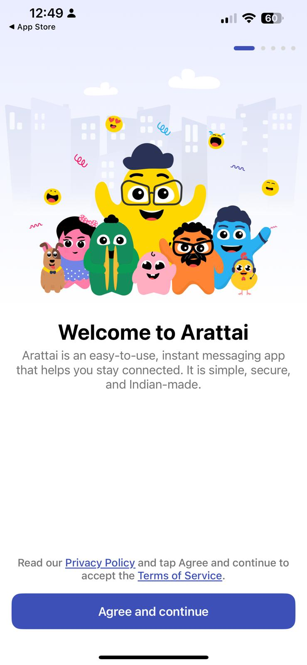
Same Agree & Continue CTA
Let us have similar page for our app when user downloads our app and when the open the app for signup process, the first page should show “Welcome to Madmonkey” and add below content “The world’s first social super app that pays you back. Every minute you spend builds rewards—and your future.”

Second page in signup page

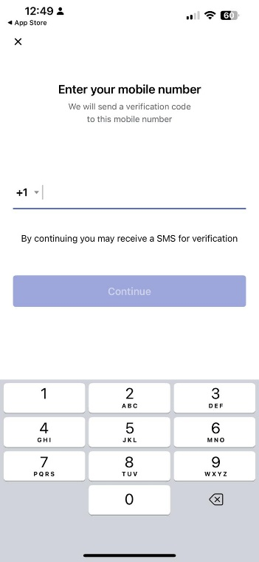
Copy the same
Third page in signup page
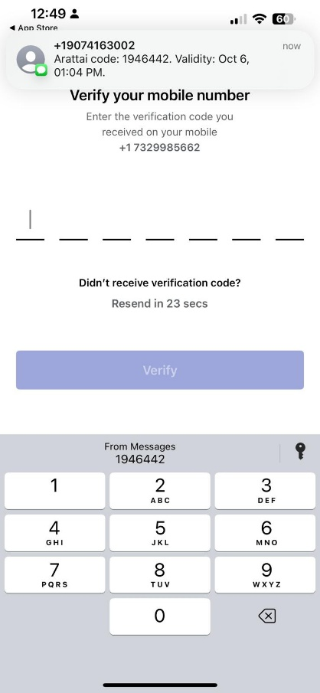
Copy the same
Fourth page in signup page

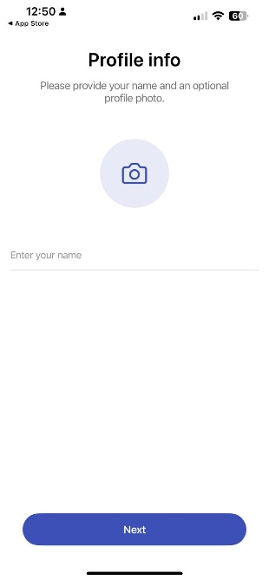
In this page we need 4 fields “Enter your name”
“Create User name” “Create Password” and “Date of Birth”
For User name: we need to tell them whether it is available or not.
Fifth page in signup page
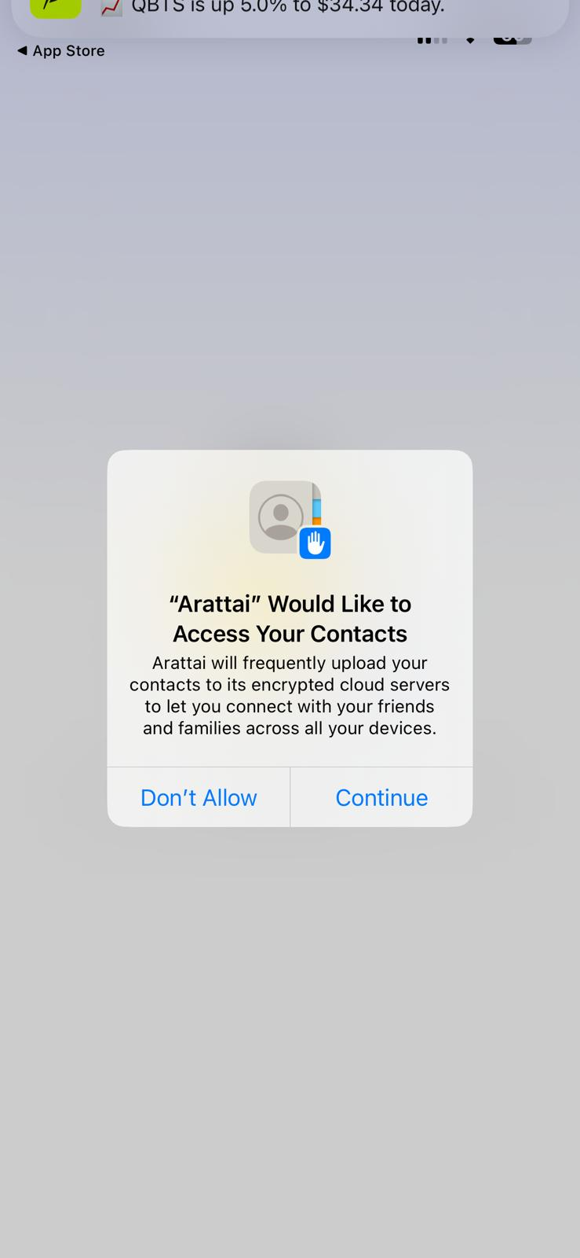
Similar screen after clicking next CTA button in the fourth page(shown above)—slightly alter the wording but should give same meaning
Sixth page in signup page
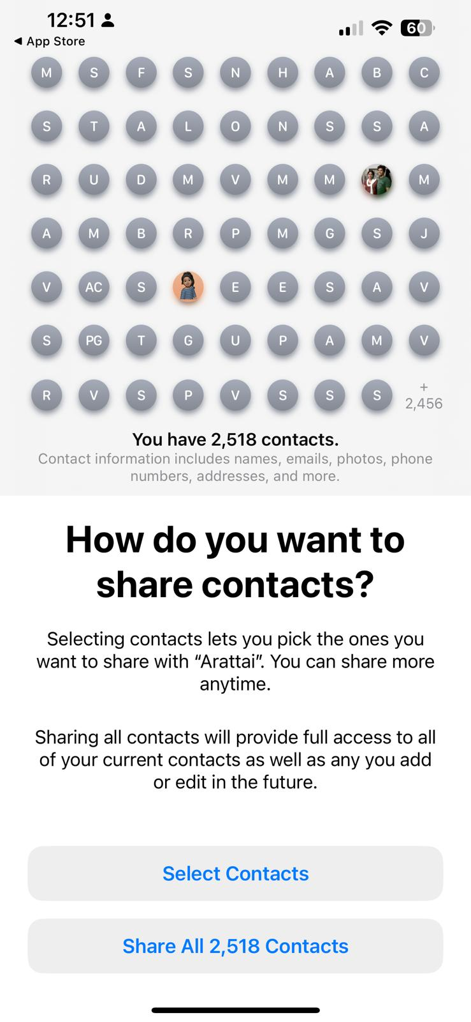
Very important section: Make similar page but slightly tweaked so that it wont look exactly same.

Our main goal is to make users to easily select contacts or share to everyone.

Seventh page in signup page
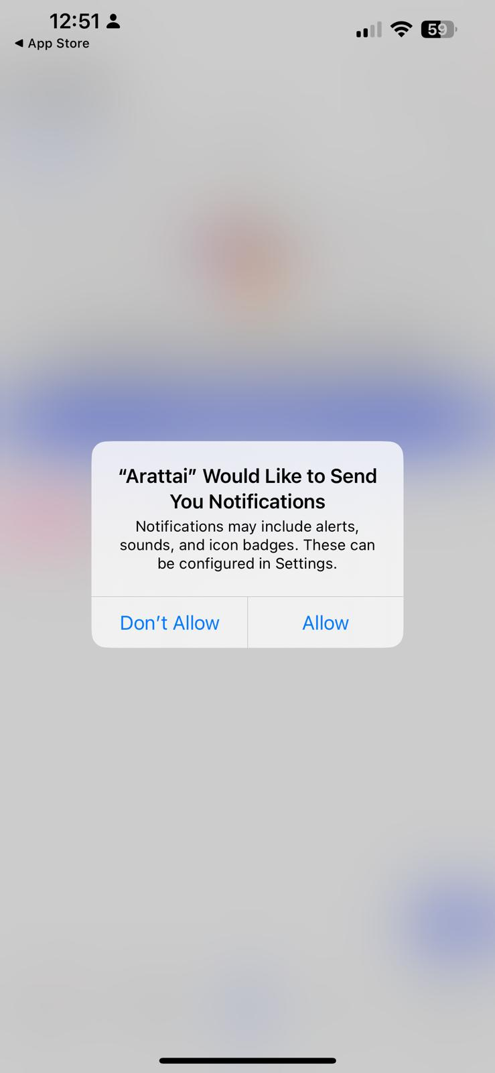
Similar page

Eighth page in signup page
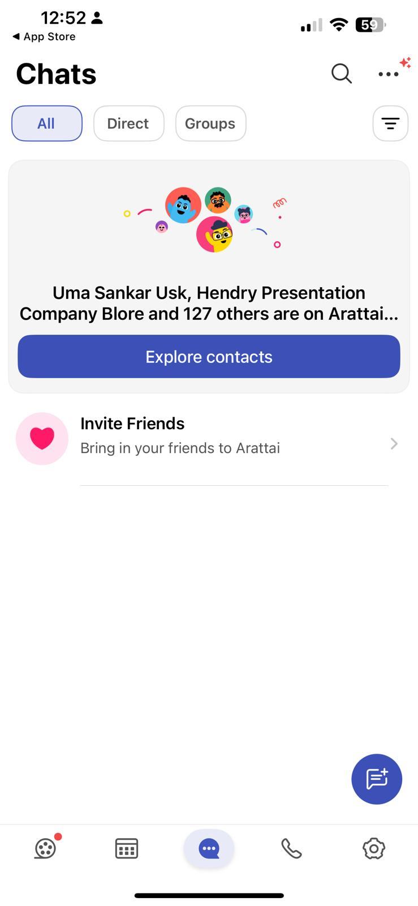
Similar page 1) Explore contacts 2) Invite friends

9th page in signup page
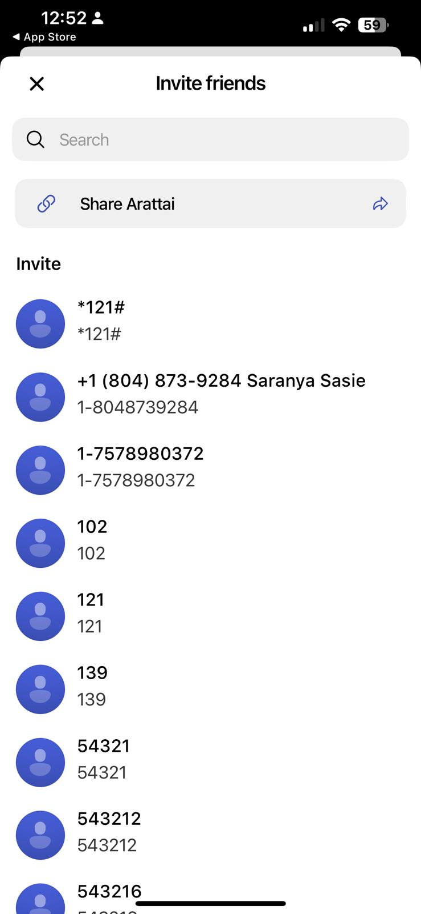
Similar page

10th page in signup
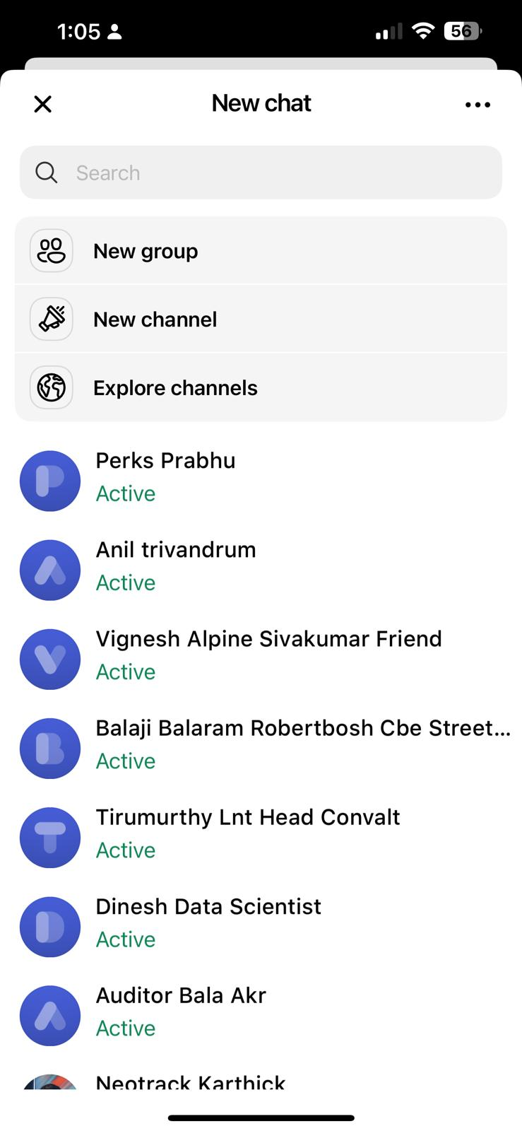
Need Similar page:

Settings Page :Very important

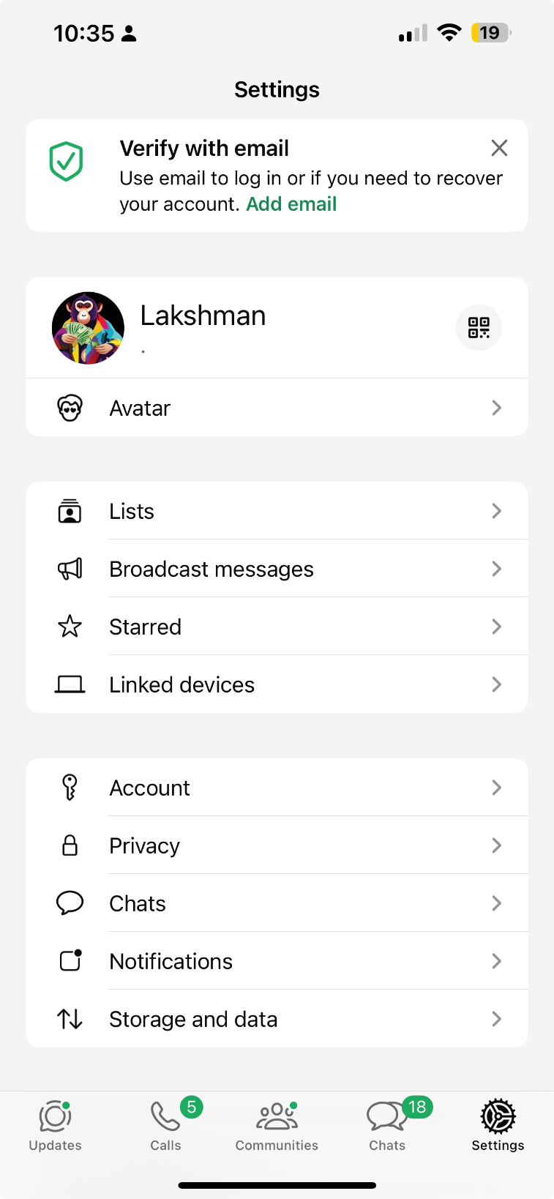

Chat window background:
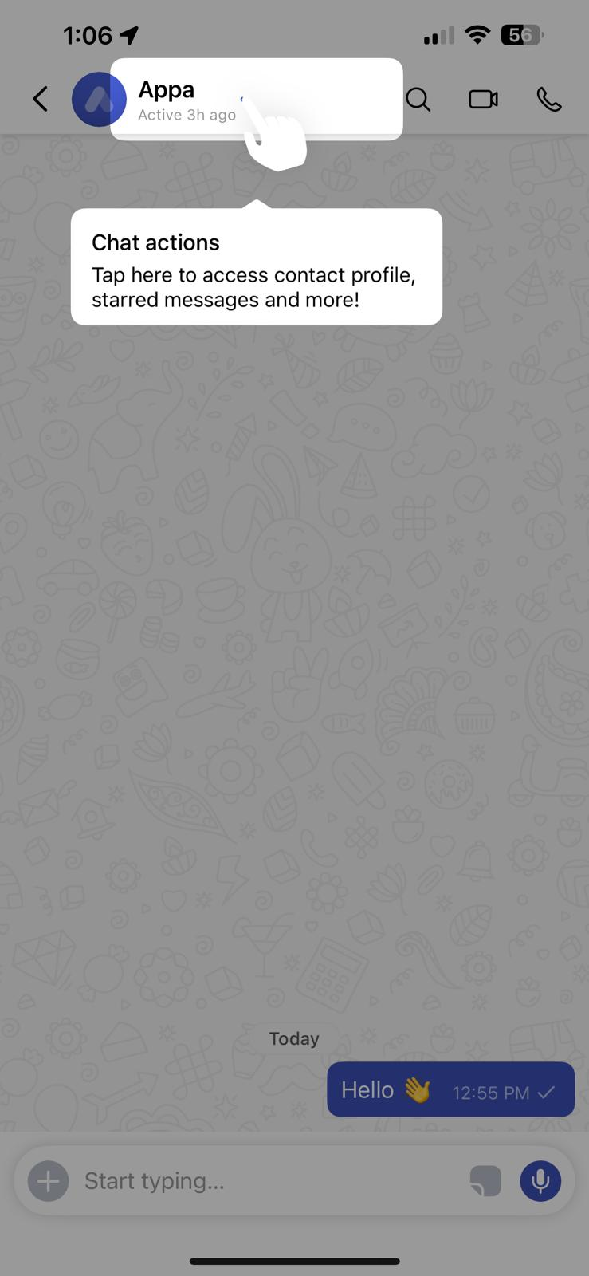
Also need Search field so that usera can search for contacts or groups or channels etc. See Arratai app, we need the same type.
Need background because its very blank in our app/ also add options to change background from the list we provide for each users/ check arratai app for ore details
Replace our Camera icon on top with these two icons

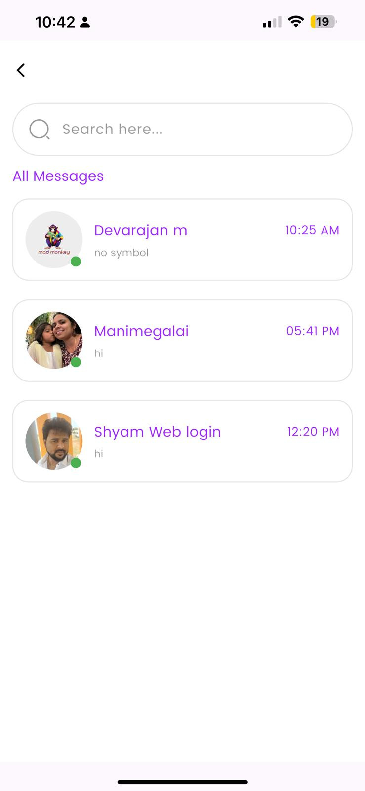
We need Setting icon and + icon here on top of search field.
Inside “+ icon”: New contacts, New group, New Channel, New Broadcast, New Community
Inside setting icon: similar to arratai/Instagram we need

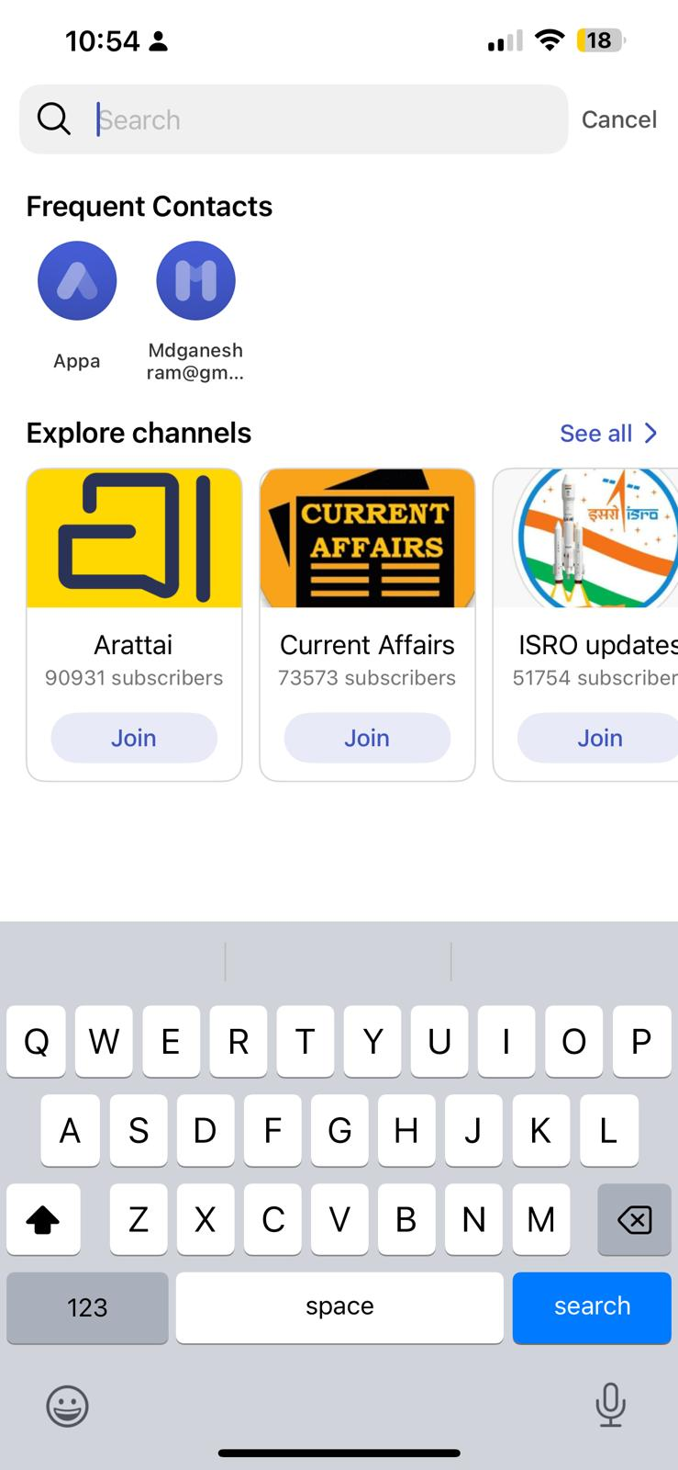
when user clicks on the “Search” section we need to show similar results in dropdown

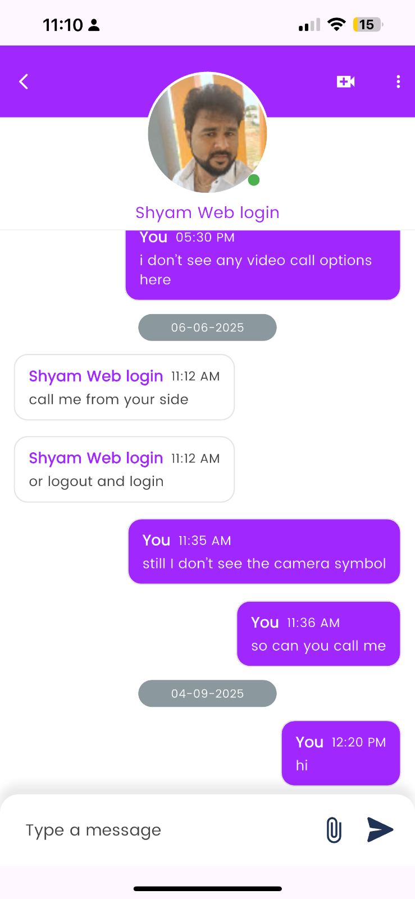
When you click on user’s friend pic or account header it should show similar to Whatsapp or Arratai. Refer these apps and we need similar actions inside each chats so that we can control each chat friend accounts.

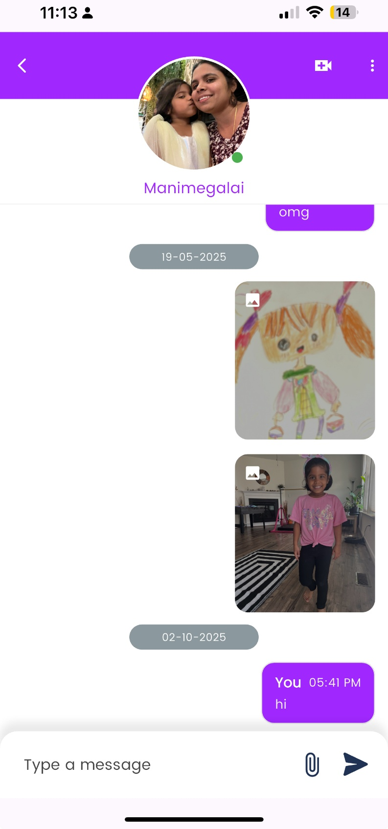
When we select each image or video we need to have options similar to Whatsapp to send “ email or forward icon to send to other, reply, info delete options ……Refer Whatsapp

